Table of Contents
Introduction of Report manager 2
Report Manager Security 3
Site Settings 3
Item Level Security 5
Subscriptions 9
Standard Subscriptions 9
Data-Driven Subscriptions 9
Managing Report Execution 11
Executing Reports with Current Data 11
Implementing Cached Instances 13
Managing Snapshots 17
Using Report History 20

Introduction of Report manager
Report Manager is a Web-based report access and management tool that you use to administer a single report server instance from a remote location over an HTTP connection. You can also use Report Manager for its report viewer and navigation features. You can use Report Manager to perform the following tasks:
- View, search, print, and subscribe to reports.
- Create, secure, and maintain the folder hierarchy to organize items on the server.
- Configure role-based security that determines access to items and operations.
- Configure report execution properties, report history, and report parameters.
- Set model item security to allow access to specific entities in the model, or map entities to predefined clickthrough reports that you create in advance.
- Create shared schedules and shared data sources to make schedules and data source connections more manageable.
- Create data-driven subscriptions that roll out reports to a large recipient list.
- Create linked reports to reuse and repurpose an existing report in different ways.
To use Report Manager, you must have Microsoft Internet Explorer 6.0 or later.
Report Manager is used only for a report server that runs in native mode. It is not supported for a report server that you configure for SharePoint integrated mode.
On a new installation, only local administrators have sufficient permissions to work with content and settings. To grant permissions to other users, a local administrator must create role assignments that provide access to the report server. The application pages and tasks that a user can subsequently access will depend on the role assignments for that user.

Report Manager Security
Overview
Reporting Services implements a role-based security model that leverages the underlying Windows security model for authentication and authorization. You can administer Reporting Services security by using the Report Manager. By default only local administrators will have access to the Report Manager; you have to grant access to other users.
There are two aspects to security: site settings and item level settings.

Site Settings

The first step in implementing Reporting Services security is to specify Site Settings. As the name implies Site Settings have to do with securing the Report Manager.
Site Settings page is used to
- Change the application title,
- Set server-wide defaults for report history limits
- Set report processing timeout values,
- Manage system-level role assignments and
- Manage shared schedules.
NOTE: You must have Content Manager and System Administrator permissions to view this page.
Name: Specify the title to use for this instance of SQL Server Report Manager. By default, the title is "SQL Server Reporting Services".
Select the default settings for report history: Select a default value for the number of copies of report history to retain. The default value provides an initial setting that establishes report history limits. You can vary these settings at the report level.
If you limit report history later, when the existing report history exceeds the limit you specify, the report server reduces the existing report history to the new limit. The oldest report snapshots are deleted first. If report history is empty or below the limit, new report snapshots are added. When the limit is reached, the oldest snapshot is deleted when a new report snapshot is added.
Report Execution Timeout: Specify whether report processing times out after a certain number of seconds. This value applies to report processing on a report server. It does not affect data processing on the database server that provides the data for your report.
The report processing timer clock begins when the report is selected and ends when the report opens. When you set this value, specify enough time to complete both data processing and report processing.
Custom Report Builder launch URL: Specify a custom URL when the report server does not use the default Report Builder URL. This setting is optional. If you do not specify a value, the default URL will be used, which launches Report Builder 1.0 as a ClickOnce application. The default URL is http://<computername>/ReportServer/ReportBuilder/ReportBuilder.application.
Apply: Click to save your changes to the report server.
Security: Click this link to open the System Role Assignments page, on which you can assign user and group accounts to predefined system roles.
Schedules: Click this link to open the Schedules page, on which you can predefine shared schedules that users can select for their reports and subscriptions.
Explanation
Launch the Report Manager. Report Manager home page will be as shown below:
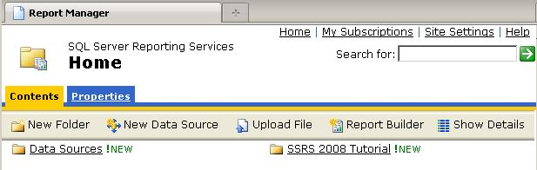
Note in the upper right hand corner the Site Settings hyperlink; click it to navigate to the Site Settings page then click the Security hyperlink; the Site Settings Security page will be displayed as shown below:
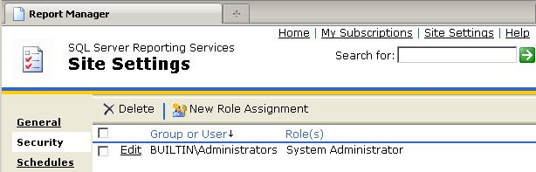
Site settings offer two roles: System Administrator and System User.
The default installation and configuration of Reporting Services adds the local administrators group to the System Administrator role. You can add any user or group that you want to administer the Report Manager to the System Administrator role. Any user or group that you want to allow access to the Report Manager content, you add them to the System User role.
New Role Assignment: Click on the New Role Assignment button to display the New System Role Assignment page as shown below:
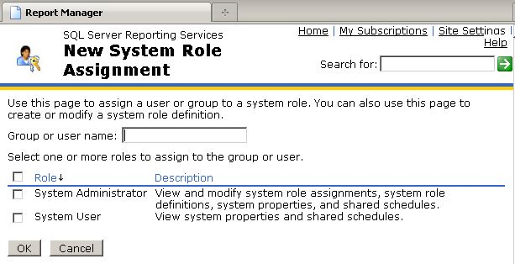
Fill in a user name or group using the format DOMAIN\USERNAME or DOMAIN\GROUPNAME. If your Reporting Services installation is on a stand-alone server (i.e. not a member of a domain) then substitute MACHINENAME for DOMAIN. Check the appropriate box to add the group or user to the System Administrator or System User role.

Item Level Security

The second step in implementing Reporting Services security is to specify Item Level Settings. As the name implies Item Level Settings have to do with securing folders, reports, and data sources.
Explanation
Launch the Report Manager. By default the Report Manager URL is http://servername/reports unless you changed it by manually configuring Reporting Services. You will see the Report Manager home page as shown below:
Click the Properties Settings hyperlink to navigate to the Security page as shown below:
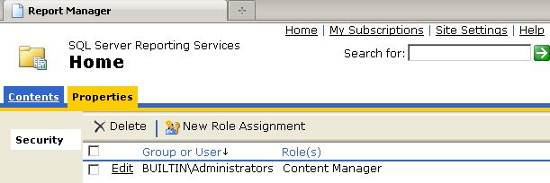
Note that the local administrators group is already added to the Content Manager role; this is done by default. Click on the New Role Assignment button to display the New Role Assignment page as shown below:
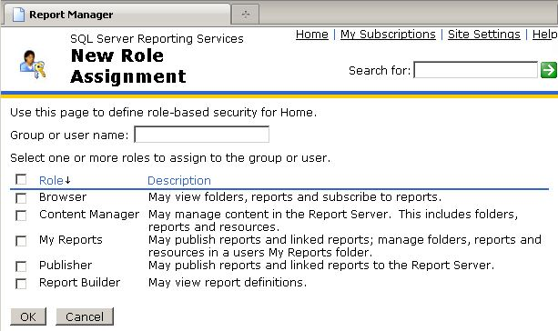
There are a number of built-in roles available for Item level security as shown above. The description provides the details of what each role is able to do. Specify the group as DOMAIN\GROUP or an individual user as DOMAIN\USER then check the appropriate role(s). For ex: If you want a group or a user to just be able to run reports, assign them to the Browser role.
When you create new folders in the Report Manager, they will automatically inherit the item level security settings of the parent folder. When you navigate to a folder, click on the Properties Settings tab then click the Security hyperlink, you will see an Edit Item Security button. If you click Edit Item Security you will be asked whether to override the security as specified in the parent folder.
Typically setting item level security at the folder level is good enough. However you can set security at the individual item level. Navigate to the desired folder as shown below:
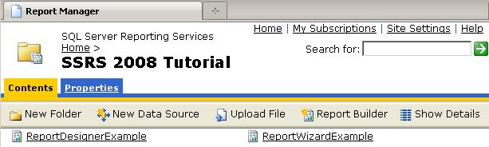
Click the Show Details button to display the detailed view as shown below:
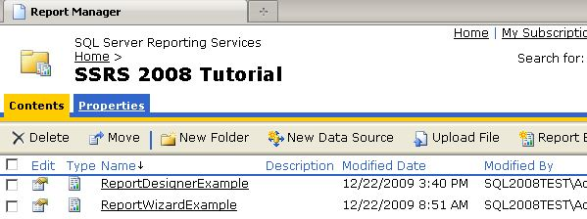
Click the icon in the Edit column for an item then click the Security hyperlink on the Properties page; you will see the Security page as shown below:
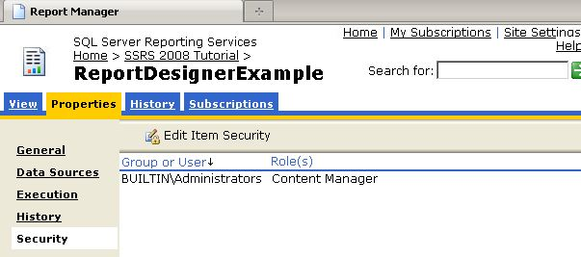
Click the Edit Item Security button to override the security settings if necessary.

Subscriptions
An important advantage to having reports available on a Report Server is that you can use its subscription features to push reports to users.
You can create subscriptions using Report Manager. Start by publishing a report to the catalog. Start Report Manager, click the Details View link, hover over a report of your choice, and then click Subscribe.

Standard Subscriptions
The first step in the Subscription dialog is to choose a delivery mode. There are two built-in delivery methods: Windows file share and Email.
NOTE: The email delivery extension requires SMTP configuration via RSCM. Subscriptions and cache refresh plans rely on SQL Server Agent, so it must be running.
In this example, choose Windows File Share as the delivery method and fill in the file name, path, render format, server credentials, and overwrite options. The next step is to pick a schedule. You can set a schedule just for this report subscription. Five recurrence patterns are available for subscriptions: Hourly, Daily, Weekly, Monthly, and Once.
If your report has parameters, you also need to decide which parameter values to supply when the report is executed as part of the subscription.
One restriction in creating subscriptions is that report data sources must rely on stored credentials, whether Windows or database credentials. Integrated security and prompted credentials are not compatible with subscriptions because the actual user isn’t around at runtime.

Data-Driven Subscriptions
Another way to customize report delivery is through data-driven subscriptions. A dynamic or data-driven subscription is very useful for delivering parameterized reports to a number of recipients whose email addresses are stored in a database, for instance. Unlike with a regular subscription, the recipient’s settings—such as the To or CC address, the title of the email, and the parameters of the report being run—can all be based on a SQL Server query.
For example, using the AdventureWorks2008R2 sample database, let’s say you want to send quarterly human resources information reports to all managers at the company.
Suppose you have created a Human Resources report that takes a parameter, the login ID of an employee. If that employee is a manager, the report displays a list of all employees reporting to him or her, together with the person’s title, the base pay rate, vacation hours, and sick leave hours.
You start the Data-Driven Subscription Creation Wizard using Report Manager by clicking the New Data-driven Subscription button on the Subscription tab for your Human Resources report. Type a name (such as Send quarterly HR reports to managers) and select the email delivery extension for the subscription. Then click Next.
On the data source page, use the shared AdventureWorks2008R2 data source you created earlier. Enter the query shown below, which selects email addresses and login IDs for all managers.

T-SQL for a Data-Driven Report Subscription

SELECT DISTINCT pe.EmailAddress,e2.LoginID FROM HumanResources.Employee e JOIN HumanResources.Employee e2
ON e2.OrganizationNode = e.OrganizationNode.GetAncestor(1)
JOIN Person.Person p
ON p.BusinessEntityID = e2.BusinessEntityID
JOIN Person.EmailAddress pe
ON pe.BusinessEntityID = e2.BusinessEntityID
ORDER BY pe.EmailAddress

Next, bind EmailAddress to the To field in the email and LoginID to the LoginID parameter of the Human Resources report. The last step is to choose a schedule for this subscription.

Subscription and Delivery Architecture
Let’s look at what happens under the covers when a subscription is created. The metadata for the subscription is validated and stored in the Report Server catalog database. A SQL Agent job is created, and the schedule specified in the subscription is saved in the SQL Agent job.
When the time comes, the SQL Agent job fires, inserting a so-called “event” row in the Report Server catalog. The Report Server matches the event with the information about the subscribers and sends notifications to the subscribers. The notifications are processed in the Report Server Windows service; the report is run and delivered to its target.
This architecture allows SSRS to scale very well with the number of subscribers and events. Because the events are recorded in the catalog database, it also allows for a scale-out configuration, so you can have a number of services process notifications in parallel, thus achieving greater scalability.

Managing Report Execution

Report execution is the process of turning a published report into a rendered report. More
Specifically, Reporting Services retrieves the data defined by the query in the dataset, and then combines the report’s layout definition with the resulting data to produce an intermediate version of the report. Reporting Services then uses a rendering extension with this intermediate report to produce the report in its final format, which is, in turn, delivered to users.

You can optimize report execution by controlling whether the processing steps occur when the user is accessing a report online or before the user opens the report.

When deciding how to manage report execution, you’ll need to balance the users’ needs for
timely data and fast response with the Report Server’s ability to process reports. If the user
Needs access to real-time data or data that is relatively recent and the report query can execute and return results in a reasonable amount of time, you can consider the On Demand execution options. When using On Demand execution, you need to decide whether to cache a report.

If users need access to historical data or a report takes a long time to process, consider
Using Scheduled execution options to maintain a snapshot or to build a history of reports on
a manual or scheduled basis. The On Demand and Scheduled execution options are compared in the following table.

 | On Demand |  | Scheduled
 | Non-Cached | Cached Instance | Snapshot | Report History
Stored Credentials | No | Yes | Yes | Yes
Storage | Each time report is opened | First time report is opened | In advance | In advance
Limits(per Report) | None | One per combination of parameter values | One | Multiple
Persistence | Temporary | Expires | Is replaced | Configure as either limited or unlimited number; specific history deletion

You can use the default execution properties for reports that query frequently changing
Source data or when there is no particular advantage to having a report ready in advance of
Browsing. If the data in a frequently accessed report needs to be relatively fresh but does not have to be as current as the data source, you can configure the report’s execution properties to use a cached instance.

Executing Reports with Current Data

When a report is configured to use the default execution properties, Reporting Services processes a report on demand each time a user requests the same report, which results in a new query for each request. The overhead of all these queries might have negative performance consequences on the source database as well as the Report Server, so you must weigh this against the benefits of providing users with access to the up-to-date data.

To improve the experience of report viewing and navigation with Report Manager, Reporting
Services uses session management. A session begins when a user opens a report for viewing in a browser or client application. After the intermediate format of the report is created, a copy is placed in the session cache, which is maintained in the SQL Server database ReportServer-TempDB. The session ends when the user closes the browser or client application. If a report’s definition changes while a user is viewing it in an active session, the user will not see the updated version of the report until the user manually refreshes the report, which retrieves the current version from the ReportServer database.

In this procedure, you’ll execute a report on demand and respond to prompted credentials.

1. In Report Manager, click the Home link, click the Folder link, and
Then click the report link to see this report:

Accordingly, the user must enter a login name and a password.
2. Enter login name and password.
3. Click View Report:

4. Now the report is visible and you can change any report parameter value to update the report. The credentials are retained in the report for use in the next query, which is triggered when you click View Report.

NOTE: Technically, the report is not executed on demand each time you view it. The
report is stored in the session (in ReportServerTempDB) and subsequent refreshes of the
page in the same session retrieve the same report. In effect, the session is a private cache
of the report. To force the report to retrieve new data, you must click Refresh on the
Report Manager toolbar.

Implementing Cached Instances

A cached instance of a report is like a session report, except that the same intermediate report can be shared between multiple users. Using a cached instance of a report reduces the number of queries to the source database and potentially improves the performance of report execution.

In this case, Reporting Services starts the process with the intermediate format of the
report, which is stored temporarily in the ReportServerTempDB database. This intermediate
report is flagged as a cached instance and is used for rendering in response to subsequent
Requests for the same report until the cached instance expires.

If a report uses query parameters, the query parameters are applied when the cached instance is created. This means that if the user selects a different parameter value that changes the value of a query parameter, a new cached instance is placed in the ReportServerTempDB database, but only if a cached instance with that parameter value doesn’t already exist. Consequently, it’s possible to have a cached instance for every combination of parameter values in a report.

Whereas a change in a query parameter triggers a new cached instance, a filter based on a
report parameter value is applied each time to the existing cached instance. In this case, each change in a filter value renders the report again without the advantage of storing the results as a cached instance.

When you change a report’s execution properties to use a cached instance, you limit the
amount of time that it persists in the ReportServerTempDB database by establishing an expiration rule for caching. You can expire a cached instance at regular intervals or according to a report-specific schedule or shared schedule. Regardless of how you choose to expire a cached instance, the report must use a data source that draws on stored credentials.

In this procedure, you’ll configure a report as a cached instance that expires on a report specific schedule.

Configure a cached instance

1. In Report Manager, click the Home link, click the Folder link, and then click the report link.
2. Click the Properties tab, and then click the Execution link

Click the third rendering option, “Cache a temporary copy of the Report. Expire Copy
Of Report On The Following Schedule” and the screen looks like this:

4. With Report-Specific Schedule selected, click Configure.

Note: If you want the cache instance of several reports to expire at the same time,
consider using a shared schedule.

5. Keep the default values, which indicate a schedule that executes on every day of the
week.
6. For the Start Time, enter 11, and then click P.M., so your screen now looks like this:

Notice at the bottom of the screen that you can optionally specify a start date or an end
date for the schedule, or both.
7. Click OK, and then click Apply to complete the configuration.
8. Click the View tab to browse the report.
A cached instance of the report was just created and will expire at 11 P.M. this evening.
If another user opens this report, Reporting Services does not execute the report query,
but instead retrieves the cached instance from the ReportServerTempDB and renders
the report for viewing.

Working with Shared Schedules

Before you can begin scheduling reports, you must define a schedule. Then, you can use the
schedule to create a snapshot of a report that can be accessed later by users, or to build a history of a report to capture information at fixed intervals of time. Although you can define a unique schedule for each report, a more efficient approach is to create a shared schedule that can trigger several activities according to the same time intervals. You can use a shared schedule to manage snapshot creation, cache expiration, and subscription delivery for multiple reports.

In this procedure, you’ll create a shared schedule to execute tasks on the first day of every
month.
Create a shared schedule
1. In Report Manager, click the Site Settings link.
2. Scroll to the bottom of the page to find the section titled Other, and then click the Managed Shared Schedules link.
3. Click New Schedule on the Report Manager Toolbar.
The Scheduling page is nearly identical to the page you used to create a report-specific
schedule.
4. In the Schedule Name box, type Beginning of Month.
5. Below Schedule Details, select Month.
6. Below Monthly Schedule, select On Calendar Days, and then replace the default value
with 1 to execute this schedule on the first day of the month.
7. In the Start Time hours box, type 05 so your screen now looks like this:

Click OK to see the schedule display on the Shared Schedules page, as shown here:

Important In order to add a Shared Schedule, SQL Server Agent must be running.
Otherwise, you will receive an error when you click OK to create the shared schedule.
You can select schedules on this page to which you want to apply an action. After you
select one or more schedules by selecting the appropriate check boxes, you can click
Delete to permanently remove a selected schedule, Pause to temporarily disable a
selected schedule, or Resume to enable a selected schedule that had been previously
paused.

Managing Snapshots

If a report is configured to render from a snapshot, Reporting Services performs the data
retrieval and processing before a user opens the report. This can be useful when you need to capture data in a report as of a particular point in time, such as a financial statement at month end, or when queries take a long time to execute, such as year-to-date queries in a large transactional database. You can create a snapshot manually, but typically, a snapshot is created on a scheduled basis to update a report with more current data. Either way, Reporting Services uses the query results and the report layout to create an intermediate report that is stored as a snapshot in the ReportServer database. When a user requests the report, Reporting Services retrieves the intermediate report for rendering and delivery to the user.
As with a cached instance, query parameters are applied when the snapshot is created. A snapshot is not an interactive report, so parameter values cannot be changed once the snapshot has been created. However, report parameter values used as filters are applied against the snapshot during browsing, which can be an alternative approach to filtering data with query parameters.

You can create a snapshot manually or on a regular basis by using either a report-specific
schedule or a shared schedule. However, only one snapshot at a time can exist. Each subsequent snapshot replaces the previous one. To configure a report to execute as a snapshot, you must select a data source that uses stored credentials for the report.

In this procedure, you’ll use a shared schedule to regularly create a snapshot for the Report.

Schedule a snapshot:

1. Click the Home link, click the Folder link, click the Report, and then click the Properties tab.
2. Click the Data Sources link, and then select the option Credentials Stored Securely In
The Report Server. Enter user name and password. Then, click Apply.

Note When you plan to schedule snapshots for a report, the report’s data source
must use stored credentials. It doesn’t matter whether you use a shared or custom data
source. You can skip this step when your report is already using a data source with
stored credentials.

3. Click the Execution link.
4. Select Render This Report From A Report Execution Snapshot, and select the Use The Following Schedule To Create Report Execution Snapshots check box, and then select
Shared Schedule.Notice that Beginning Of Month is available in the Shared Schedule drop-down list. Because it is the only shared schedule, it is automatically selected. The schedule details appear below the selected schedule.

To prevent a snapshot from being created now, clear the Create A Report Snapshot
When You Click The Apply Button on this Page check box so your screen now looks
like this:

6. Click Apply.

NOTE: If the data source you’re using for the current report is not using stored credentials,
you will get the following error message when you click Apply: “Credentials used to
run this report are not stored.” You must change the data source to use stored credentials
before you try to assign a snapshot schedule to the report”.

Click the View tab to view the error message that is displayed when a snapshot is not yet
ready:
The report will not be available until it executes for the first time, which will be the first
day of the next month.

Using Report History
If you want to save snapshots for future reference, you can enable a report’s history properties. Then, you can add a snapshot to report history manually or automatically each time a snapshot is created. Alternatively, you can use a schedule to update report history with the current snapshot, which Reporting Services creates if a current snapshot doesn’t already exist. Because the report is executed as a snapshot, the report must use a data source that draws on stored credentials.

Although you can keep an unlimited number of snapshots in report history, you might want
to establish a maximum limit to keep the number of accumulated snapshots under control.
You can set a global limit to apply to all reports that use report history, but you can override
this number for any report. You can change the global or report-specific limit any time, but be careful when decreasing the number of snapshots in history. The oldest snapshots will be eliminated immediately. You can also delete individual snapshots in report history manually, but there isn’t a utility for deleting report history in bulk apart from deleting the report itself.

In this procedure, you’ll configure report history to store all report snapshots.

Store snapshots in history
1. Click the Properties tab of the Report, and then click the History link.
2. Select Store All Report Execution Snapshots In History.
3. Below Select The Number Of Snapshots To Keep, select Limit The Copies Of Report History, and then type 12 in the box so your screen looks like this:

4. Click Apply, and then click OK to confirm the message that warns you about changing
the report history.
5. Click the Execution link.
6. Select Create A Report Snapshot When You Click The Apply Button On This Page, and
then click Apply.
7. Click the View tab.
You can view the report now that a snapshot is created ahead of schedule. Notice that
you cannot change the report parameter values.
8. Click the History tab to confirm that your screen looks similar to this:

The snapshot you created manually is now available in the History list and is listed by
date and time of creation. The list will grow as the Beginning of Month shared schedule
executes each month. When the thirteenth snapshot is added to the list, the oldest snapshot
will be deleted from the list so that only 12 snapshots are in the list, as defined in
the History properties.

NOTE You can click New Snapshot on the History tab of the current report to add
snapshots to the list manually. This button is enabled only when the report uses a data
source with stored credentials and the option to Allow Report History To Be Created
Manually is enabled on the History Properties page.

